**Problem Statement**:

**You work for XYZ Corporation. Your corporation is working on an application and they require secured web servers on Linux to launch the application**.

**1. Create an instance in the US-East-1 (N. Virginia) region with Linux OS and manage the requirement of web servers of your company using AMI.**

**2. Replicate the instance in the US-West-2 (Oregon) region.**

**3. Build two EBS volumes and attach them to the instance in the US-East-1 (N. Virginia) region.**

**4. Delete one volume after detaching it and extend the size of the other volume.**

**5. Take backup of this EBS volume.**

Step 1:

Created an instance in US-East-1(N.virginia)region with Linux OS.

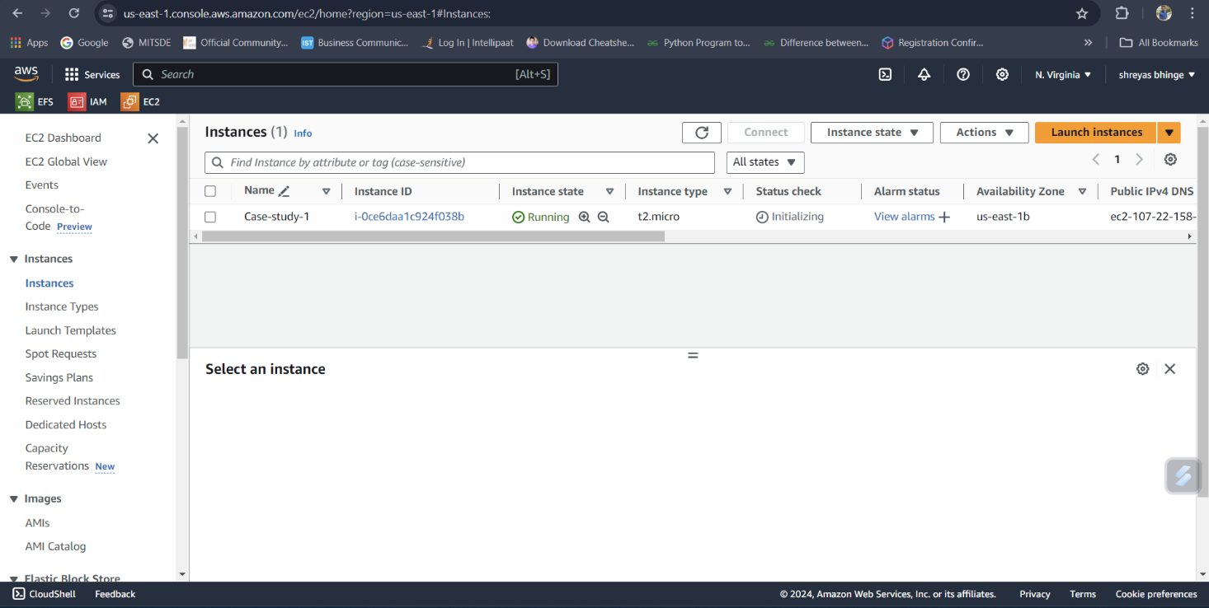

Step II:

Replicate the instance in the US-West-2 (Oregon) region.

* Once the instance is launched in US-East-1 region, create an AMI of the instance.
* Copy the AMI to the US-West-2 region.
* Launch an instance in the US-West-2 region using the copied AMI

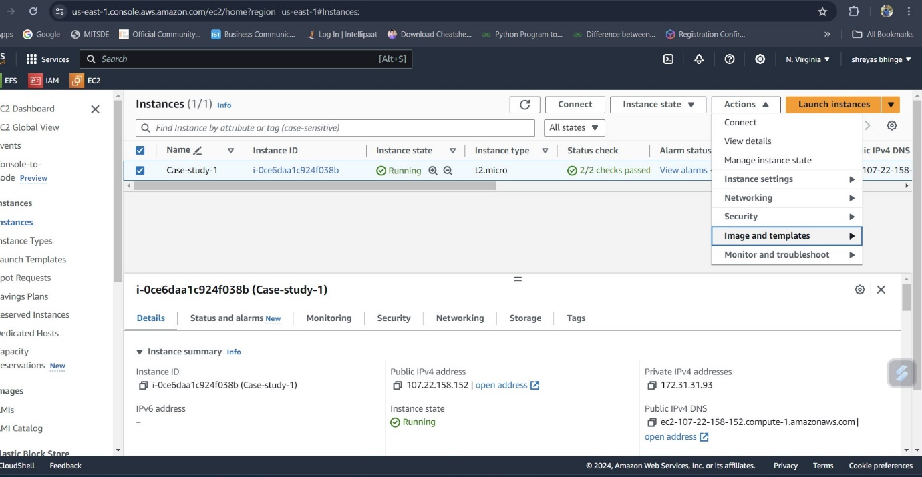

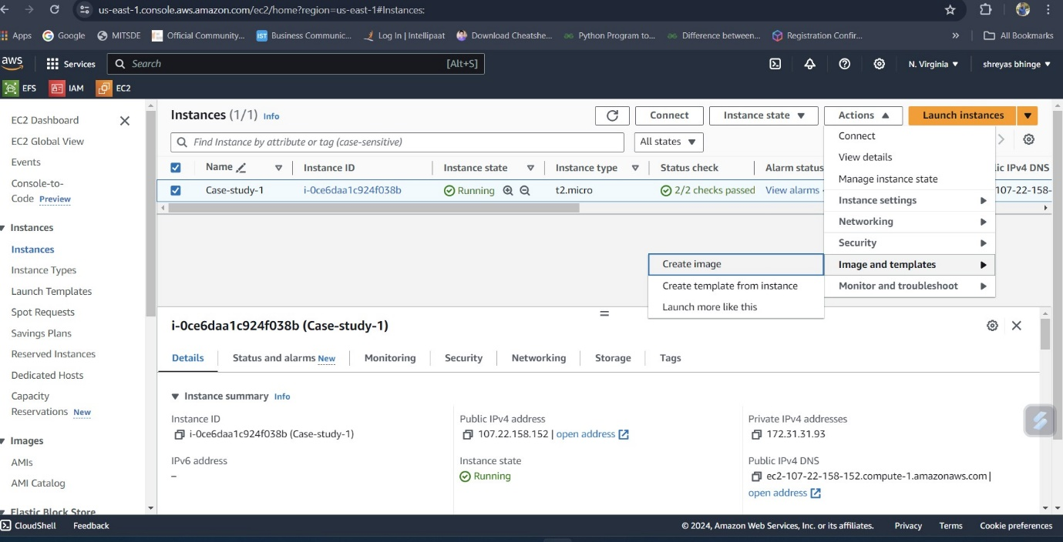

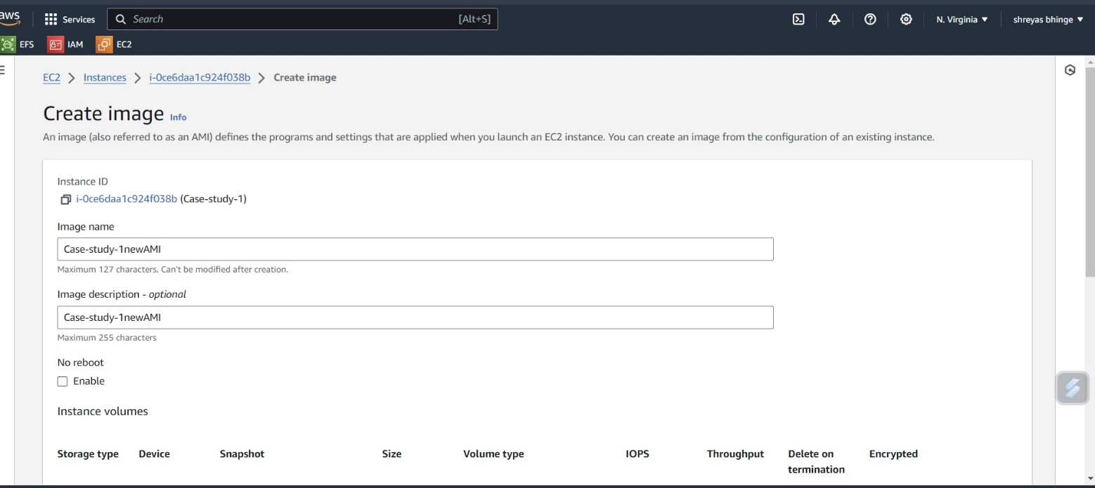

* Copy the AMI to the US-West-2 region.

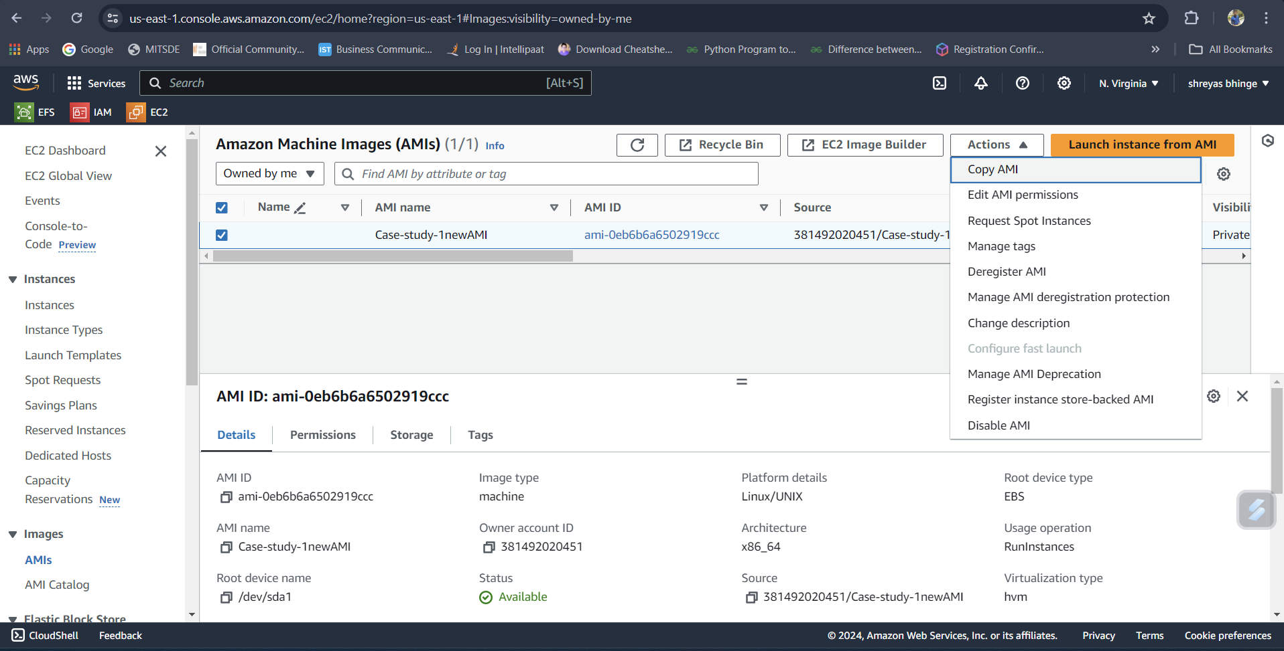

Step III:

Attached two EBS volume to the instance in the US-East-1 (N. Virginia) region.

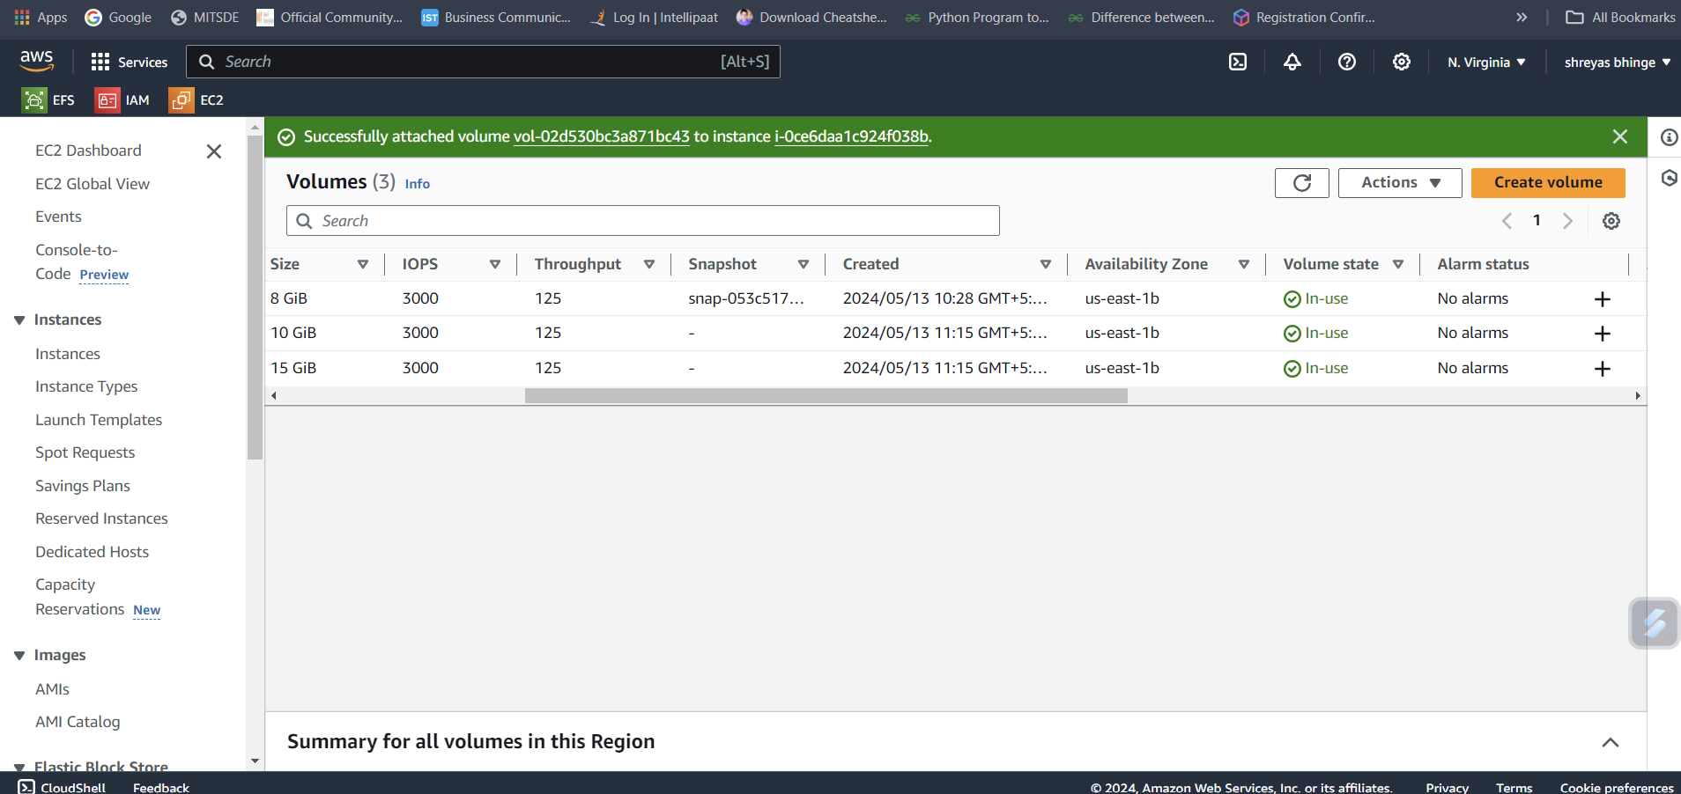

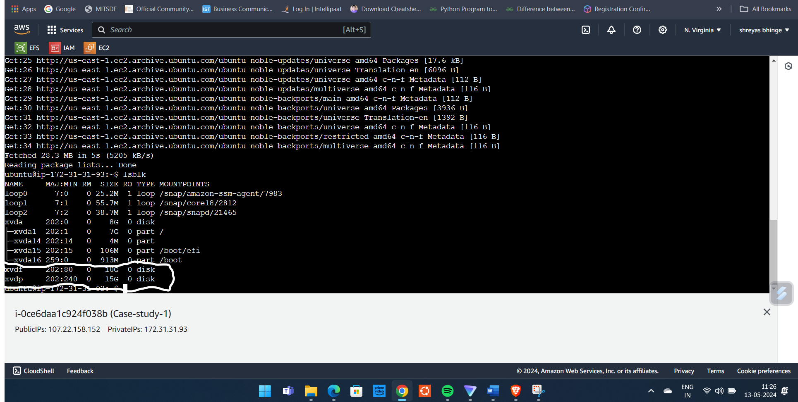

Step IV:

1. Delete one volume after detaching it and extend the size of the other volume.

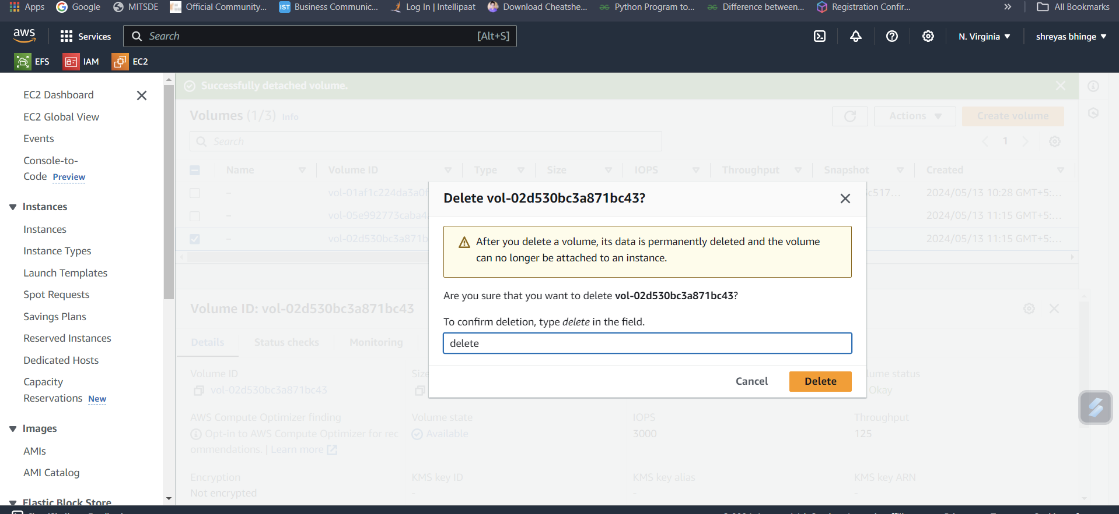

1. Increased volume size from 10GB to 20 GB.

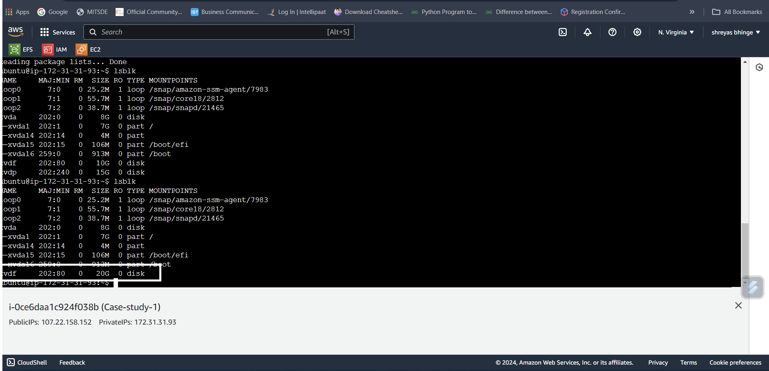

Step V:

Take backup of this EBS volume.

